**Date: 07-08-2021**

**Experiment 1**

**Aim:** To work with MATLAB operators, expressions, variables and library functions.

**Apparatus:** MATLAB Software

**Objective:**

1. To learn the basics of MATLAB software.
2. To be aware of MATLAB operators like addition, subtraction, multiplication, division etc.
3. To learn how to write expressions in MATLAB.
4. To learn different types of variables and how to work with.
5. To know different inbuilt library functions and their syntax.

**Theory:**

**Steps to open the MATLAB software**

1. Search MATLAB Software Online
2. Create your own workspace
3. Start working on your desired folder

**Different windows in MATLAB**

1. **Command Window**

Here different, easy and quick commands can be executed in short time**.**

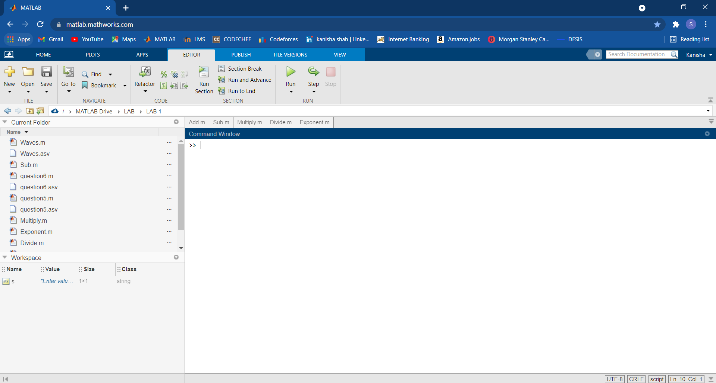

1. **Workspace**

Here every variable state is signified with its Name, class, size etc.



1. **Current Folder**

We can navigate from one specified folder to other using this facility.



1. **Editor Window**

We need to write our code here which we need to for our desired outcome.

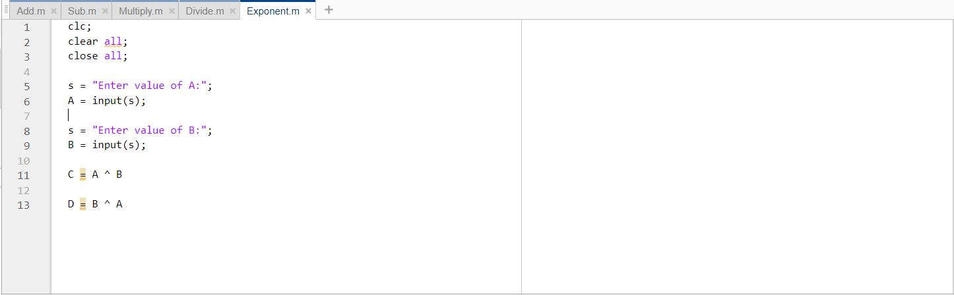

**Operators**

1. **Addition ‘+’:**

**Code:**

clc;

clear all;

close all;

s = "Enter value of A:";

A = input(s);

s = "Enter value of B:";

B = input(s);

C = A + B

**Output:**

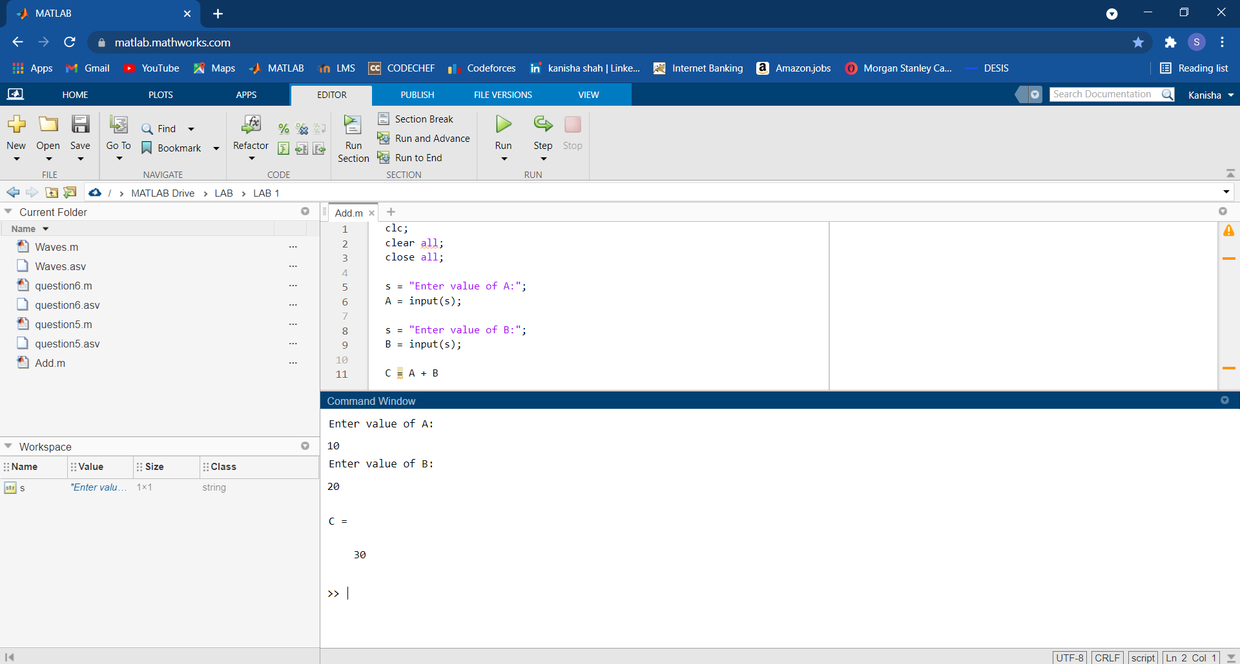

1. **Subtraction ‘-‘:**

**Code:**

clc;

clear all;

close all;

s = "Enter value of A:";

A = input(s);

s = "Enter value of B:";

B = input(s);

C = A – B

**Output:**

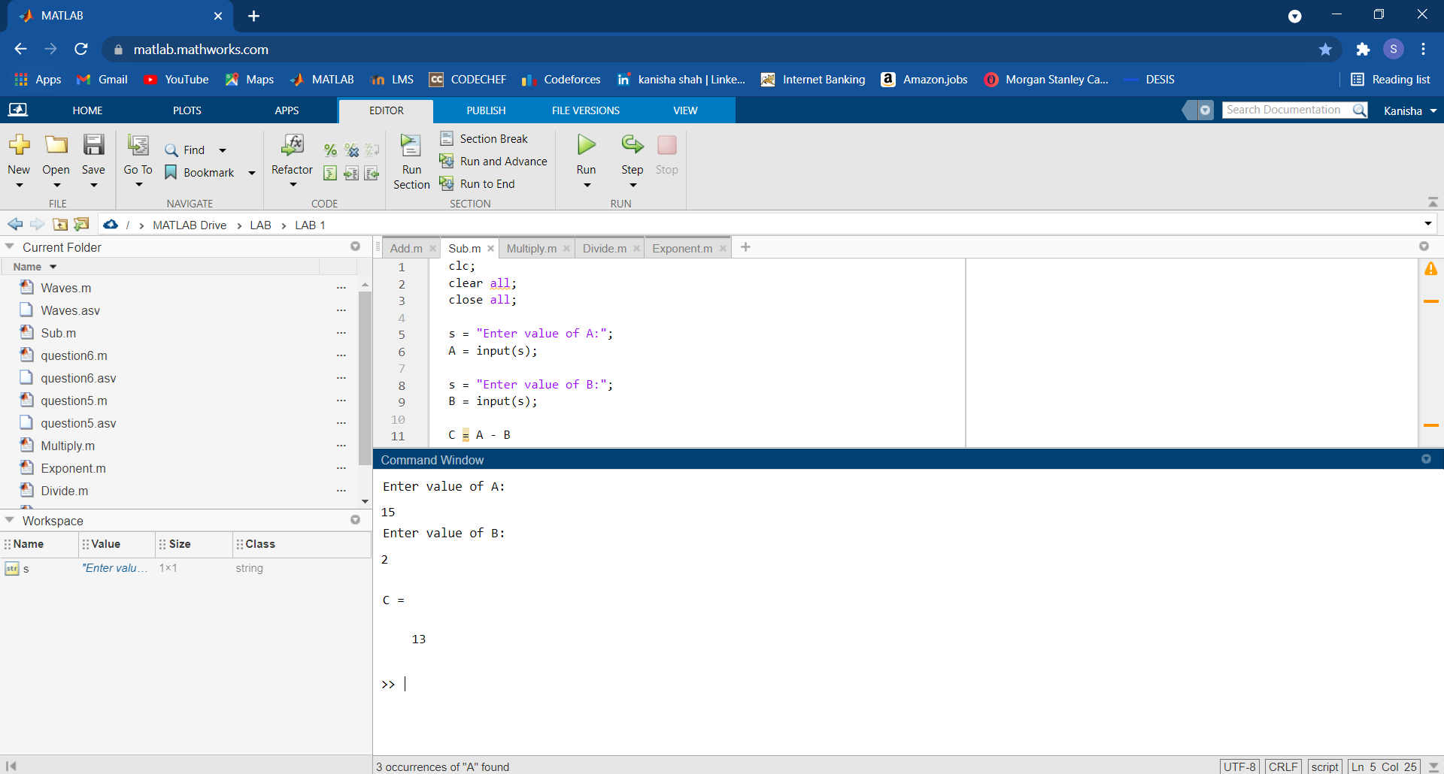

1. **Multiplication ‘*’:**

**Code:**

clc;

clear all;

close all;

s = "Enter value of A:";

A = input(s);

s = "Enter value of B:";

B = input(s);

C = A * B

**Output:**

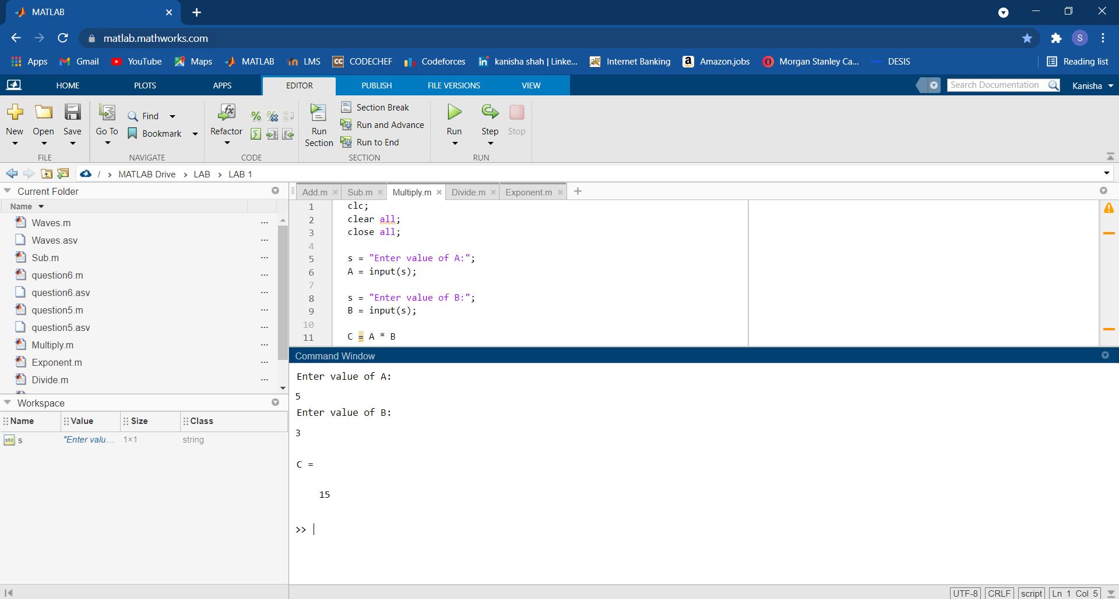

1. **Division ‘/’:**

**Code:**

clc;

clear all;

close all;

s = "Enter value of A:";

A = input(s);

s = "Enter value of B:";

B = input(s);

C = A / B

D = A \ B

**Output:**

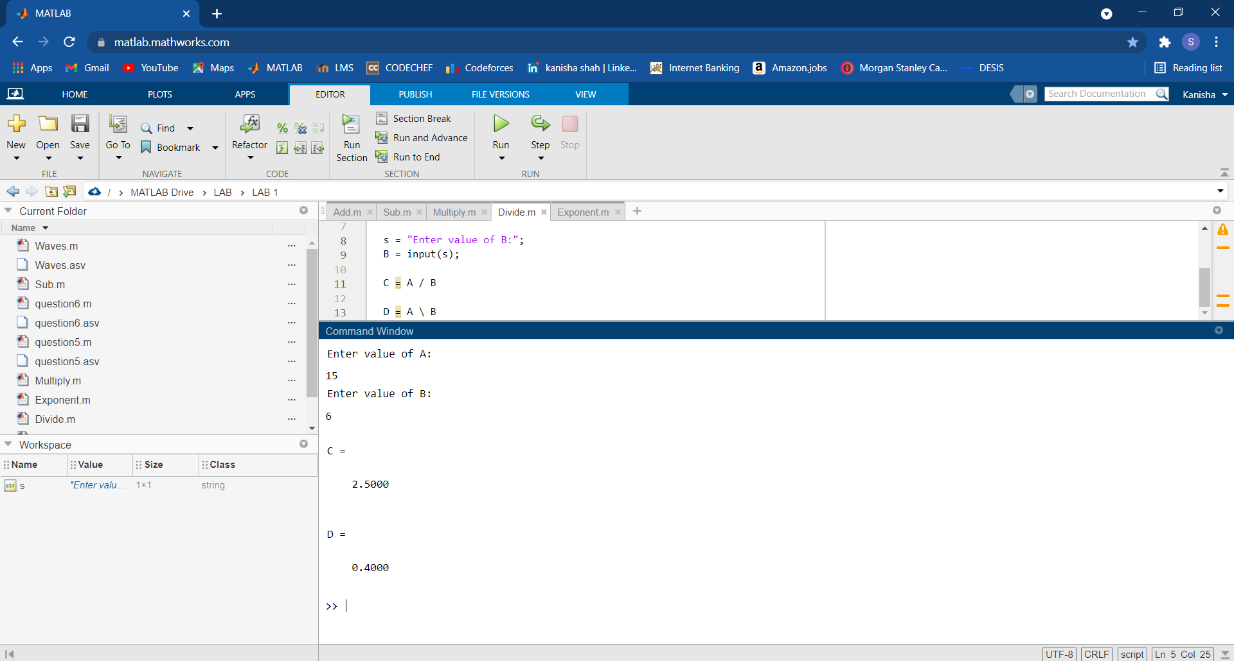

1. **Exponentiation ‘^’:**

**Code:**

clc;

clear all;

close all;

s = "Enter value of A:";

A = input(s);

s = "Enter value of B:";

B = input(s);

C = A ^ B

D = B ^ A

**Output:**

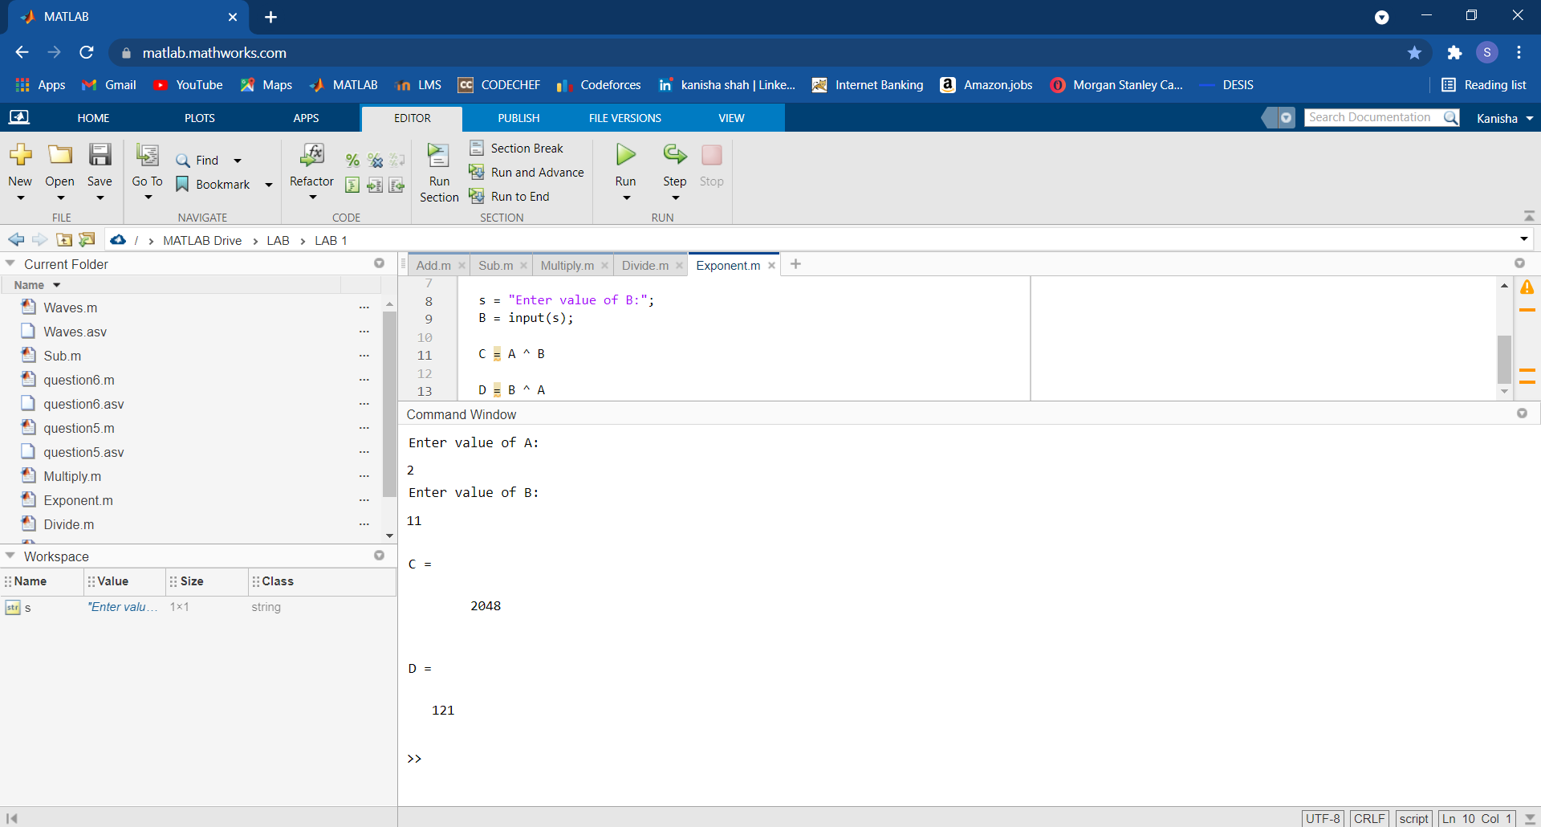

**Basic Commands**

**Code:**

clc;

%clear all;

close all;

x = 0:0.1:10;

sinx = sin(x);

figure

subplot(2,1,1)

plot(x,sinx);

xlabel('X')

ylabel('Sinx')

cosx = cos(x);

subplot(2,1,2)

plot(x,cosx);

xlabel('X')

ylabel('Cosx')

figure

trin = sawtooth( x , 0.5 );

plot(x,trin);

hold on

%pulse = pulstran( x , d , func );

%plot(x,pulse);

trin1 = sawtooth( x , 0.1 );

plot(x,trin1);

legend('Triangular1','Triangular2')

**Output:**

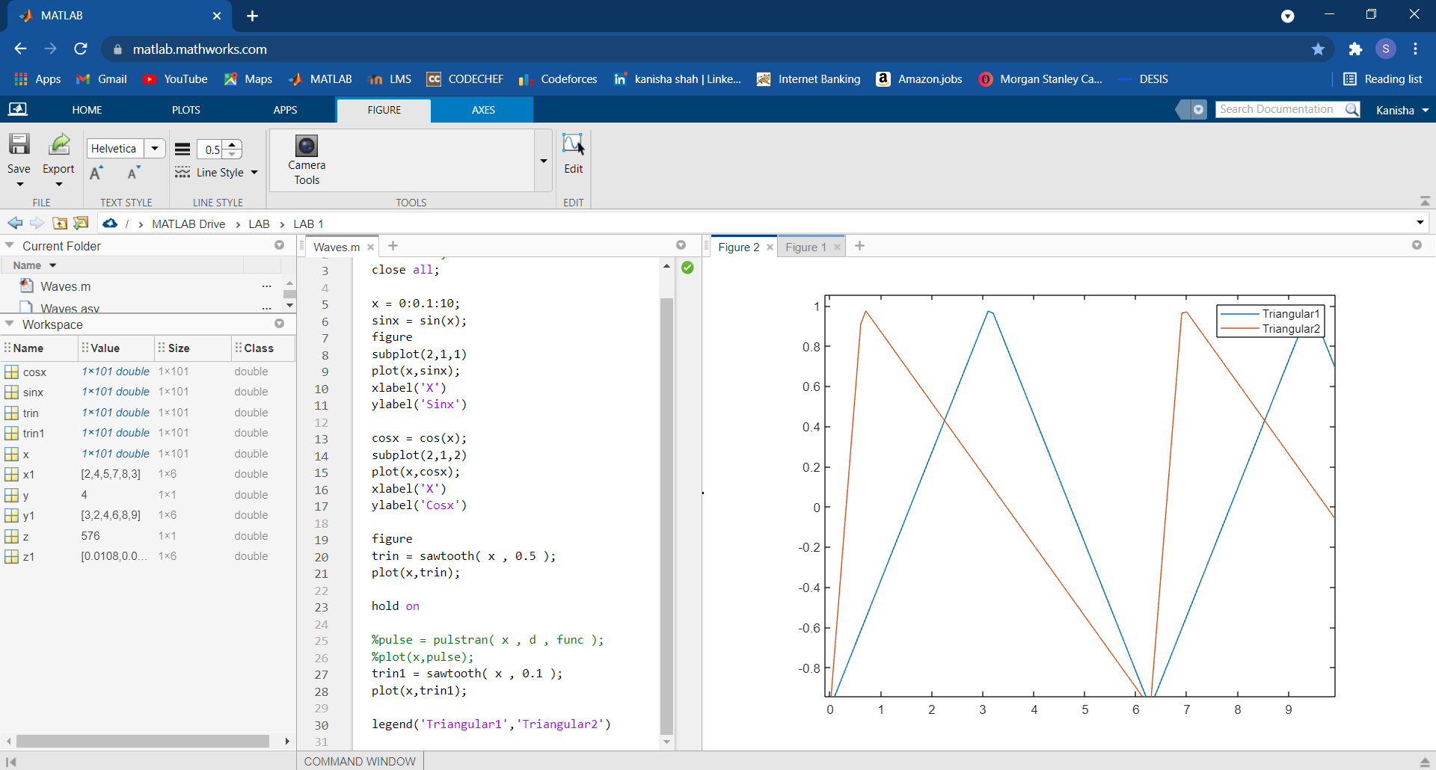

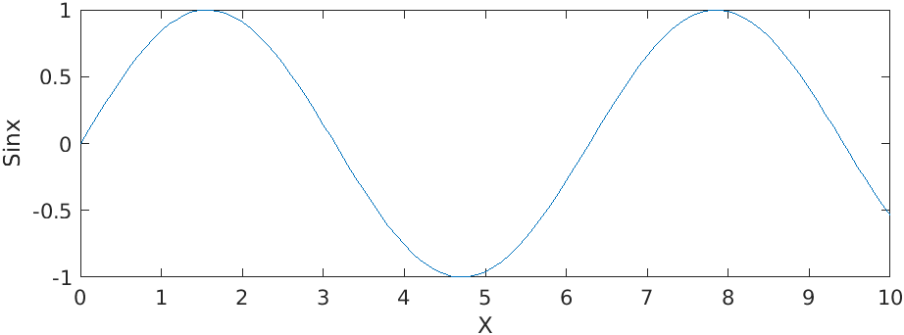

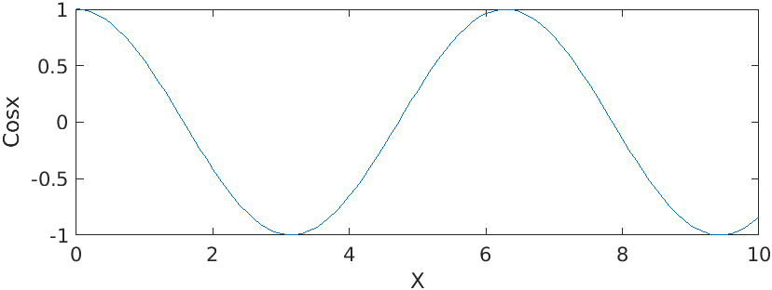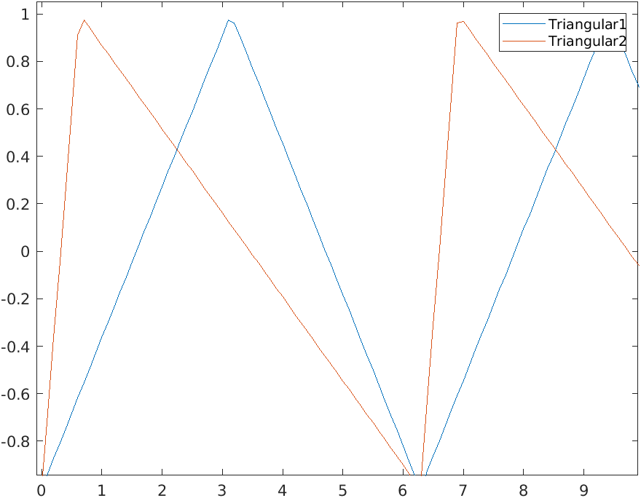

* **Sin(x) –** Function is used for plotting sin function
* **Cos(x)** – Similarly function is used for plotting cos function
* **Plot (x, y) –** It plots a continuous graph of X verses Y
* **Subplot (x, y) –** It plots a Sub-Graph where X is common for n number of graphs.
* **xlabel (‘ ‘) –** It attaches a X axis Label
* **ylabel (‘ ‘)–** It attaches a Y axis Label
* **figure –** It opens a new figure window
* **title (‘ ‘) –** It gives a Caption for Graph
* **sawtooth(x , 0.5 )** – It is helpful to form a Triangular Graph
* **legend(‘’,’’)** – It is useful to add a Legend in graph for better understanding

**Quiz:**

* + 1. What is the purpose of the MATLAB Command Window? The Edit Window? The Figure Window?

**Ans:**

Command window is basically used for performing quick operations which you do not want to be saved and even for supplying the input of the code which gives us an output. Edit Window is used for writing code of which we want to perform the required task. Figure window is used for showing graphs as per the inputs.

* + 1. List the different ways that you get help in MATLAB.

**Ans:**

We can use **Editor, Command Window, or Help browser**; right-click; and then select Help on Selection. As when you are using any inbuilt function the MATLAB suggests you about the function too, that is one part of help.

3. What is a workspace? How can you determine what is stored in a MATLAB workspace?

**Ans:**

Workspace is a place where we can find our declared variables with its specified **Name, Value, Size and Class**. You can view and edit the contents of the workspace in the Workspace browser or in the Command Window.

4. How can you clear the contents of a workspace?

**Ans:**

We can clear the workspace by simply writing ‘clear all’ in **Command Window** or in the **Edit Window** (in the code). We can even take help **of Workspace browser**

5. The distance travelled by a ball falling in the air is given by the equation

Use MATLAB to calculate the position of the ball at time *t* =5 s if

**Code:**

clc;

%clear all;

close all;

x0 = 10;

v0 = 15;

t = 5;

a = -9.81;

x = x0 + v0*t + (0.5 * a * (t*t)); %applying formula

t1 = [1,3,5,6];

x1 = x0 + v0.*t1 + (0.5 * a * (t1.*t1));

subplot(2,1,1) % using subplot

plot(x1,t1); %it plots a continuous graph

xlabel('Time')

ylabel('Velocity')

%hold on;

subplot(2,1,2)

stem(x1,t1); %it plots a discrete graph

xlabel('Time') %It helps for recognition purpose

ylabel('Distance')

%legend('x','x1')

**Output:**

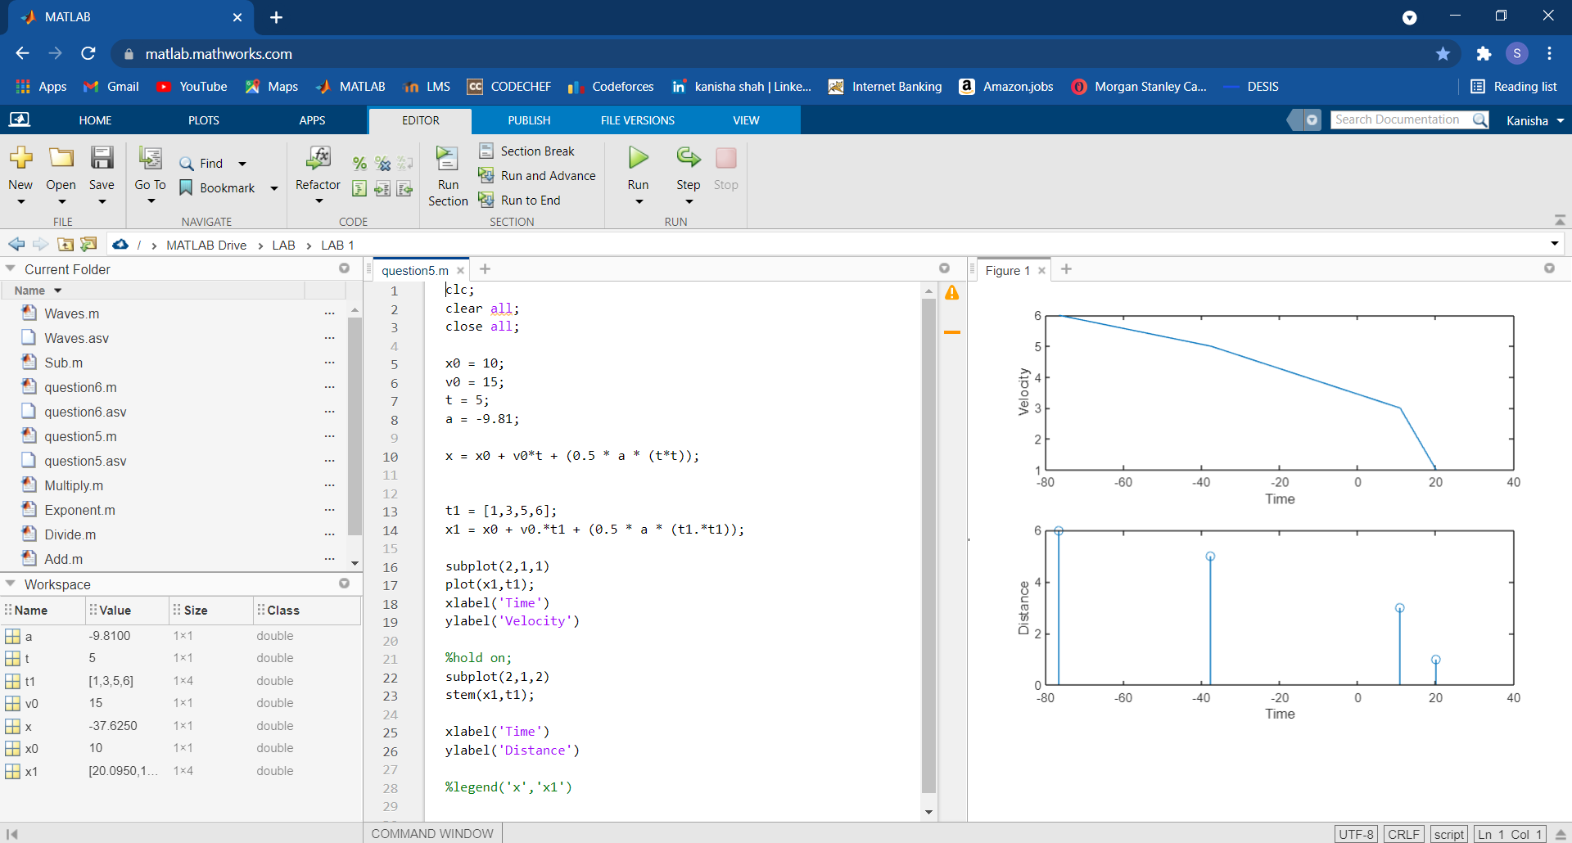

1. Suppose that *x=3* and *y=*4. Use MATLAB to evaluate the following expression:

**Code:**

clc;

%clear all;

close all;

figure

x = 3;

y = 4;

z = ( x^2 * y^3 ) / (x - y) ^ 2

plot(x,z) %Here it is plotted for a single value

figure %Opening a new window

x1 = [2,4,5,7,8,3];

y1 = [3,2,4,6,8,9];

z1 = ( x1.^2 .* y1.^3 ) ./ ((x1 - y1).^ 2)

plot(x1,z1) %Similarly it is plotted for a range of values

**Output:**

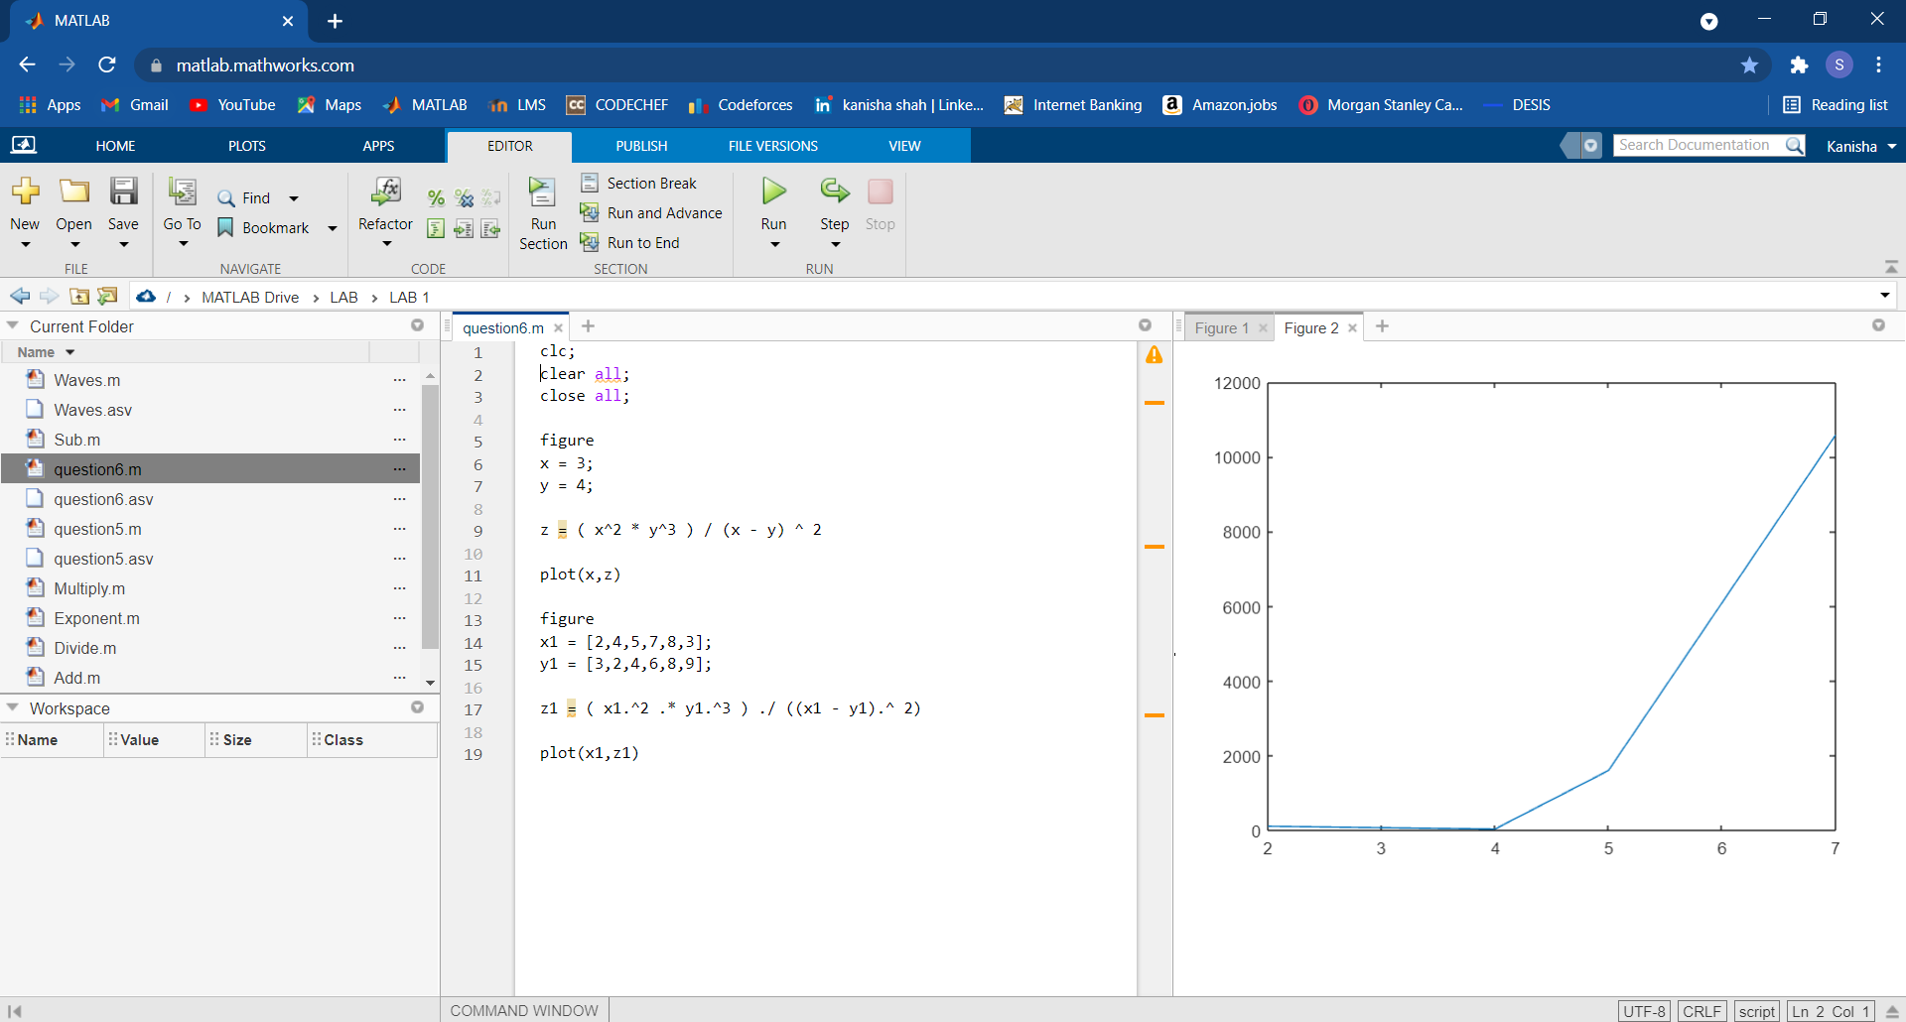

**Conclusion:**

From this practical we came to know about the basic functionalities of MATLAB and different already present modules. The modules can be very useful for future uses. We understood different ways to plot different types of graphs using inbuilt functions as well as performing manually. The lab was very useful to brush-up the concepts of MATLAB.